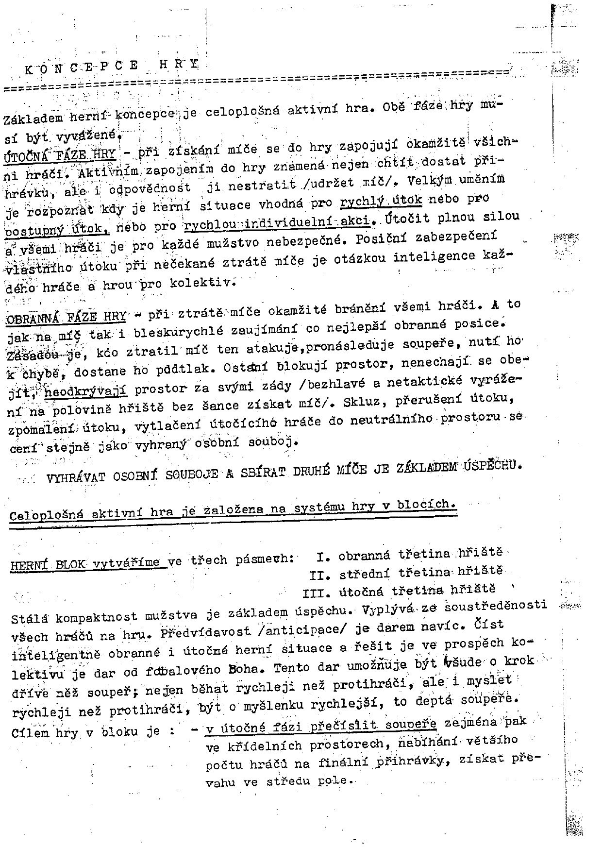

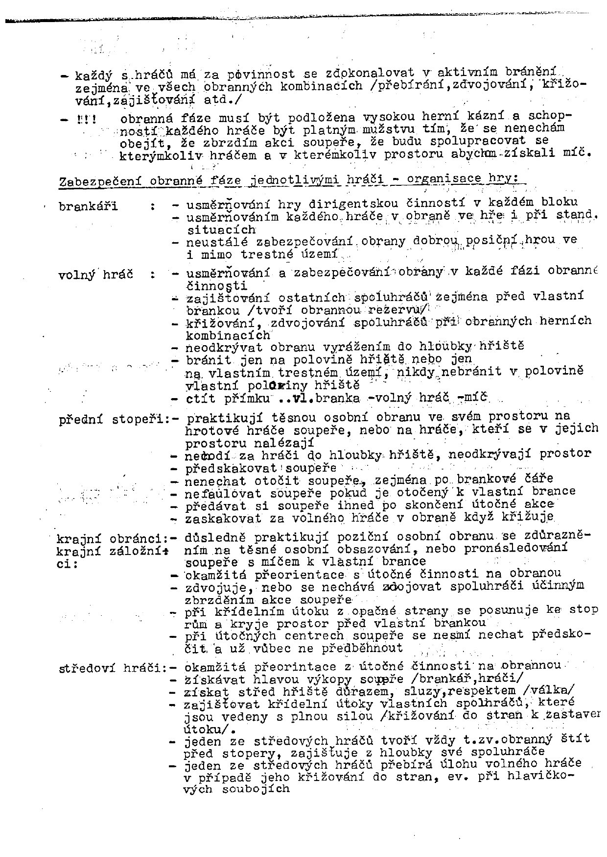

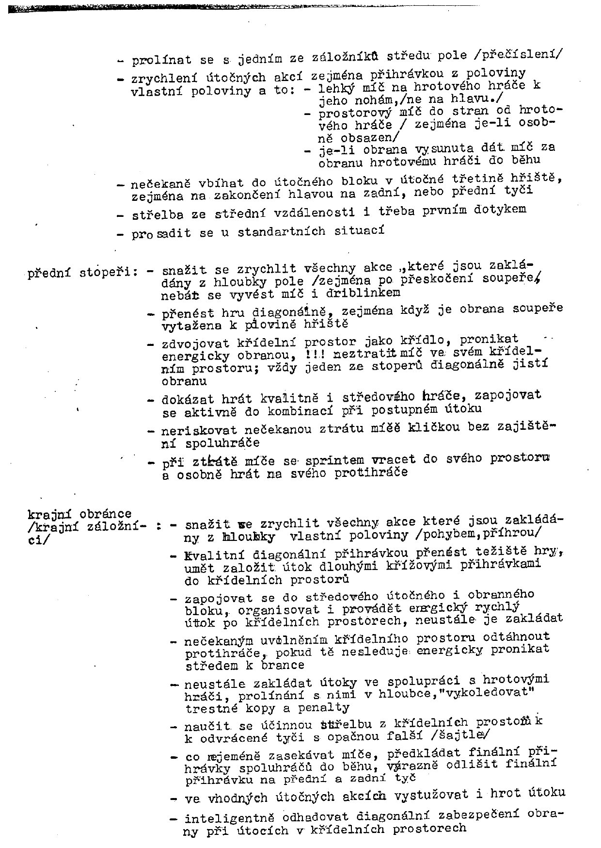

**Thank you for evaluating AdreamSoft PDF to Word**

**You can only convert 3 pages with the trial version**

**To get all the pages converted, you need to purchase the software from**

[*http://www.allpdftools.com/purchase/buy-pdf-to-word.html*](http://www.allpdftools.com/purchase/buy-pdf-to-word.html)